Process Design for the Production of Ethylene oxide by oxidation of Ethylene

Process Design for the Production of Ethylene oxide by oxidation of Ethylene

Abstract

This project considers oxidation of ethylene using compressed oxygen as a means to mass-produce ethylene oxide. The basic outlines of the production design are as follows:

i). Ethylene, compressed Oxygen and recycle gas are mixed and then fed into a catalytic reactor.

ii). The mixture is passed over a silver oxide catalyst supported on an absorptive carrier at 200-

300oC and 10–30 bar.

iii). The gases from the reactor are first cooled and passed through a scrubber where the ethylene

oxide is absorbed as a dilute aqueous solution. This process of reactor gas stream clean up

includes the removal of the CO2 using physical sorbents (such as heated potassium carbonate).

iv). The resulting ethylene oxide can then go straight to ethylene glycol manufacture or purified by

fractionation for use in other ethylene oxide derivatives

**Process Design for the Production of Ethylene Oxide by oxidation of Ethylene**

Design Project By:

Akshay Srivastava

Shreshth Jain

Presented To:

IE Nandana Chakinala

(Dept. ChE. Manipal University Jaipur)

Table of Contents

|  |  |  |  |
| --- | --- | --- | --- |
|  | **Section** | | **Page** |
|  |  |  |  |
| I. | Abstract | |  |
| II. | Introduction | |  |
| III. | Process Flow Diagram and Material/Energy Balances | |  |
| VI. | Utility Requirements | |  |
| VII. | Economic evaluation | |  |
| IX. | Safety | |  |
| X. | Acknowledgements | |  |
| XII. | Bibliography | |  |
|  |  | |  |
|  |  | |  |
|  |  | |  |
|  |  | |  |

**Abstract**

Abstract:

The basic outlines of the production design are as follows:

i). Ethylene, compressed Oxygen and recycle gas are mixed and then fed into a catalytic

reactor.

ii). The mixture is passed over a silver oxide catalyst supported on an absorptive carrier at

200-300oC and 10–30 bar.

iii). The gases from the reactor are first cooled and passed through a scrubber where the

ethylene oxide is absorbed as a dilute aqueous solution. This process of reactor gas

stream clean up includes the removal of the CO2 using physical sorbents (such as

heated potassium carbonate).

iv). The resulting ethylene oxide can then go straight to ethylene glycol manufacture or

purified by fractionation for use in other ethylene oxide derivatives

**INTRODUCTION**

**Background**

Ethylene oxide is a colourless flammable gas produced by the oxidation of ethene in the presence of a silver catalyst. Because the bonds in the ring are easily broken so epoxyethane is a highly reactive compound and hence it easily participates in addition reactions, allowing it to easily polymerize into larger compounds. It therefore has a range of uses in the chemical sector.

The major industrial application of ethylene oxide is as a key raw material in the production of many industrial chemicals and intermediates, including (Shell Chemicals, 2009):

* *Ethylene glycols* –used in the production of antifreeze, polyester and polyethylene
* *Terephthalate* (PET, the raw material for plastic bottles), liquid coolants and solvents.
* *Polyethylene glycols* - used in perfumes, cosmetics, pharmaceuticals, lubricants, paint thinners and plasticizers
* *Ethylene glycol ethers* - used as a key component of brake fluids, detergents, solvents, lacquers and paints
* *Ethanol amines* - used in the manufacture of soap and detergents and for purification of natural gas
* *Ethoxylates* – (produced through reaction of ethylene oxide with higher alcohols, acids or amines) in the manufacture of detergents, surfactants, emulsifiers and dispersants

Global production of ethylene oxide was around 19 million metric tons in both 2008 and 2009, having increased slightly from 18 million tonnes in 2007 (SRI Consulting, 2009). This places ethylene oxide as the 14th most produced organic chemical worldwide - the most produced organic chemical was ethylene with 113 million tonnes (SRI Consulting, 2009). Ethylene oxide was first manufactured by BASF in 1914 using ethylene chlorohydrin (reaction of ethylene chlorohydrin with calcium hydroxide) as an intermediate (selectivity of this reaction path was 80%), but this route has been superseded by the direct oxidation of ethylene with air or oxygen. This was so since practically all of the chlorine that was used was lost as calcium chloride and unwanted chlorine-containing by-products were generated. This not only was inefficient, but also caused pollution problems so that this method has now been replaced by the direct oxidation process. Currently, nearly all the world’s ethylene oxide production capacity is based on direct oxidation, with oxygen generally preferred over the air route in larger.

**Reaction**

The oxidation reaction of ethylene to ethylene oxide is as follows

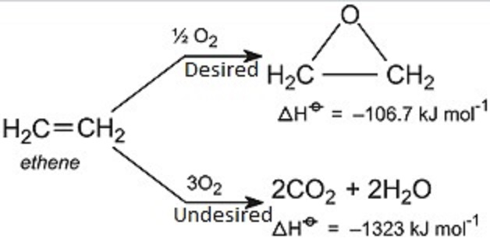

In the mentioned reaction, ethylene is oxidised in the presence of compressed oxidised. The reaction can have two outcomes, one in which the one mole of ethene reacts with half moles of oxygen to produce one mole of ethylene oxide, and the other one in which one mole of ethene reacts with 3 moles of oxygen to produce 2 moles of each steam and carbon dioxide (which is done by the formation of acetyl aldehyde, which upon further oxidation yields steam and carbon dioxide). Out of the two reactions, the production of ethylene oxide is magnified by the presence of reactor conditions mentioned and that of the latter are minimised. The mentioned reaction takes place in the presence of a Silver oxide catalyst bed. To maximise the reactor conditions, the reactor temperature is maintained at 200-300oC and the pressure at 10-30 bar.

**Basic physical properties of ethylene oxide**

|  |  |
| --- | --- |
| Appearance | Colorless Gas |
| Boiling Point | 10.7°C |
| Density | 0.882 g/ml |
| Melting Point | −111.3°C |
| Molar Mass | 44.05 g/mol |
| Solubility | Miscible |

**Section III**

**Process Flow Diagram and**

**Material/Energy Balances**

**Basic Block flow diagram**

The basic block flow diagram is given below:

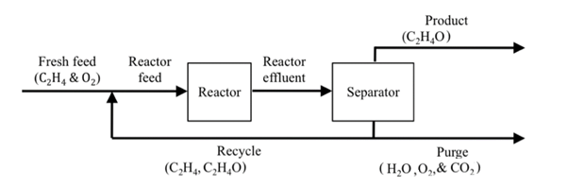

The fresh feed (which contains ethylene and oxygen) is fed into the rector as reactor feed. The reactor which operates at 10-30 bar and 200-300°C converts the reactor feed to Ehtylene oxide (selectively) and also to water and carbon dioxide (by-product) by the principles of the following chemical reaction equations.



The converted and unconverted species as then fed into a reactor which then separates out the undesired and desired products. Species such as ethylene and ethylene oxide are fed back into the reactor along with the feed stream, whereas components such as water, oxygen and carbon dioxide are purged out of the reactor assembly.

The following basic material balance can be applied to the reactor:

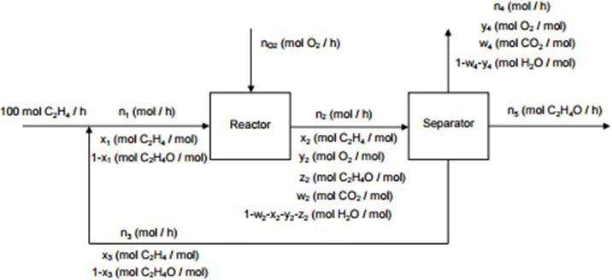

**MATERIAL BALANCES:**

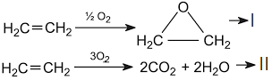

*Assuming that (i). The reaction only operates at 70% efficiency.*

*(ii). 100 Kmoles/hr of Ethylene is fed into the reactor*

*Hence 30% of total feed is recycled.*

*30 moles of C2H4 is recycled (out of the reactor)*

*70 moles of C2H4 participates in the reaction*

*Assuming that 70% of net C2H4* ***participating*** *in the reaction proceeds through* ***reaction-I*** *and the remaining 30% proceeds through* ***reaction-II***

mol C2H4 **---I**

70 – 49 = 21 mol C2H4 **---II**

For reaction I:- mol O2

49 mol C2H4O obtained from 49 mol C2H4

For reaction I :- 21 mol of C2H4

21X3= 63 mol O2

42 mols H2O

42 mol CO2

*selectivity* =

*Assuming 100moles/hr (C2H4)*

Total O2 required :

Reaction I : 29.5 moles

Reaction II : 63.0 moles

Total : 87.5 moles

*Assuming we put in 100 moles O2:-*

100-87.5= 12.5 moles in excess

Hence $\frac{12.5}{100}×100=12.5 \%$ excess O2

Hence 12.5 moles O2 is purged

Net E.O.= 49 moles = 2156 kg

Net Ethyl = 30 moles= 840 kg

Net O2 = 12.5 moles = 400 kg

Net CO2= 42 moles = 1848 kg

Net H2O = 42 moles = 756 kg

ENERGY BALANCES

Basic Energy Balance Equation :-

mCp∆T(reactant) + ∆H + Q(exothermic reaction)= mCp∆T(products)

assuming the feed is at 25°C and 1 atm:-

∆T=25°C-25°C=0

Hence mCp∆T=0

Q= Heat released by the exothermic reaction

mCp∆T(product)={[(m1*CpI)ethylene + (m2*CpII)O2 + (m3*CpIII)ethylene oxide + (m4*CpIV)H2O] –

[ Tproducts – Treactants]}-----3

Assuming that the reactor is operating at 280°C:-

Hence ∆T= 280-25= 255°C

Applying to equation 3:-

mCp∆T=255X[2156X1714.5+840X2409.25+1848X1046.88+400X988.3+756X1858]

=2411004722 J

Therefore, Heat of Formation required for the reaction = 2411004722 J

∆HR = Heat of reaction E🡪EO+ Heat of reaction **-II**

Taking data from previous calculations:-

-106.7 KJ/mol X 49= -5228.3 J

-1323 KJ/mol X 21= -27783 J

= -33011.3 J

Heat that should be supplied = 2411004722 J – 33011.3 J= 2410971711 J

Utility Requirements

A few of the utilities required and a basic description of each of the utilities is given below:

**Heat Exchangers**

Heat exchangers are devices used to transfer heat energy from one fluid to another. Typical heat exchangers experienced by us in our daily lives include condensers and evaporators used in air conditioning units and refrigerators. Boilers and condensers in thermal power plants are examples of large industrial heat exchangers. There are heat exchangers in our automobiles in the form of radiators and oil coolers. Heat exchangers are also abundant in chemical and process industries. There is a wide variety of heat exchangers for diverse kinds of uses, hence the construction also would differ widely. However, in spite of the variety, most heat exchangers can be classified into some common types based on some fundamental design concepts.

A heat exchanger is a device that is used to transfer thermal energy (enthalpy) between two or more fluids, between a solid surface and a fluid, or between solid particulates and a fluid, at different temperatures and in thermal contact.

**Reactors**

Since oxidation of ethylene is highly exothermic, reaction in a fluidized bed would appear to be appropriate. However, attempts to develop such a process on a commercial basis have not produced any advantages for selectivity, and have led to problems due to abrasion and sintering. As a result, all ethylene oxide plants currently employ fixed-bed tubular reactors. The diameter of the tubes must not be excessive so as to ensure sufficient heat transfer to the heat transfer medium. A tube diameter of 20 – 40 mm is common. The diameter of the catalyst particles has an upper limit determined by the need for satisfactory gas mixing and a lower limit resulting from an increasing drop in pressure. A diameter of3–8mm is used.

**Separator (CO2 Stripping)**

Stripping is mainly conducted in trayed towers ([plate columns](https://en.wikipedia.org/wiki/Plate_column)) and [packed columns](https://en.wikipedia.org/wiki/Packed_column), and less often in [spray towers](https://en.wikipedia.org/wiki/Spray_towers), [bubble columns](https://en.wikipedia.org/wiki/Bubble_column_reactor), and [centrifugal contactors](https://en.wikipedia.org/wiki/Centrifugal_extractor). Trayed towers consist of a vertical column with liquid flowing in the top and out the bottom. The vapor phase enters in the bottom of the column and exits out of the top. Inside of the column are trays or plates. These trays force the liquid to flow back and forth horizontally while the vapor bubbles up through holes in the trays. The purpose of these trays is to increase the amount of contact area between the liquid and vapor phases. Packed columns are similar to trayed columns in that the liquid and vapor flows enter and exit in the same manner. The difference is that in packed towers there are no trays. Instead, packing is used to increase the contact area between the liquid and vapor phases. There are many different types of packing used and each one has advantages and disadvantage

Basic Calculation of atom economy

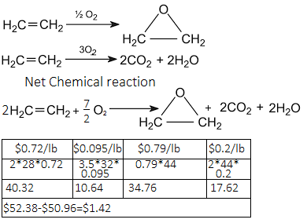

*Above prices may vary from source

Safety regarding EO handling and production:

Ethylene oxide (EtO) is produced in large volumes and is primarily used as an intermediate in the production of several industrial chemicals, the most notable of which is ethylene glycol. It is also used as a fumigant in certain agricultural products and as a sterilant for medical equipment and supplies. Unfortunately, EtO possesses several physical and health hazards that merit special attention. EtO is both flammable and highly reactive. Acute exposures to EtO gas may result in respiratory irritation and lung injury, headache, nausea, vomiting, diarrhea, shortness of breath, and cyanosis. Chronic exposure has been associated with the occurrence of cancer, reproductive effects, mutagenic changes, neurotoxicity, and sensitization.